Lab 12: Ballistic Pendulum

Group Submission
Yoaneli Ortiz, Trung Vo, Patrick Ignaut, Marjory Cevallos

PHYS 1401
College Physics -1

3/3/2025

TABLE OF CONTENTS

Objective 3
Equipment 3
Theory and Equations 4
Procedure 5
Data and Observations 5
Calculations 10
Results 13
Sources of Error 13
Discussion 14
Conclusion 14

OBJECTIVE:
The purpose of this experiment is to measure the initial velocity of a projectile in two independent ways: One by treating it as a projectile and using the kinematic equations, and the other is by applying the conservation of linear momentum and energy to a ballistic pendulum. An optional part compares spring potential energy, ball kinetic energy and ball gravitational potential energy.

EQUIPMENT:
Meter stick (x2) | Plastic ball | Ballistic Pendulum | Triple beam balance
White paper | Carbon paper | Tape | Pencil

THEORY AND EQUATIONS:
Physics is the study of measures, which involves reading many different things. Because of this, it is important to learn how to measure things correctly and figure out what they mean. It's important to note that the measuring tool used determines the number of significant figures that need to be kept in a reading. Two meter rulers, a plastic ball, and a ballistic pendulum will be used to measure different items in this experiment. The error that is likely to be made in these measurements will also be found. A triple-beam balance (or an electronic balance if one is available) will be used to measure the mass of the ball and the pendulum with the ball inside. A meter stick will be used to measure the center of mass of the pendulum.

Equations:
The equations of motion for a projectile are:
x-direction: y-direction:
V_{xf} = v_{xi} + a_{x}(t_{f} - t_{i}) v_{yf} = v_{yi} + a_{y}(t_{f} - t_{i})
X_{f} = x_{i} + v_{xi}(t_{f} - t_{i}) + 12a_{x}(t_{f} - t_{i})² y_{f} = y_{i} + v_{yi}(t_{f} - t_{i}) + 12a_{y}(t_{f} - t_{i})²
v_{xf}² = v_{xi}² + 2a_{x}(x_{f} - x_{i}) v_{yf}² = v_{yi}² + 2a_{y}(y_{f} - y_{i})

Percent Error: $\% error = \frac{\left|Accepted value - Computed value\right|}{Accepted value }x100(\%)$
V₀ = Initial velocity of the ball
m = mass of the ball
M = mass of the pendulum
V₁ = common velocity of pendulum+ball just after collision.
From conservation of momentum (i.e. initial momentum = final momentum), we get:
Initial momentum of ball = final momentum of pendulum+ball.
Or
mV_{o} = (m + M)V₁ ( 1 )
After the collision, the pendulum+ball swings upwards, with an initial velocity V₁. As it swings up, the kinetic energy of the pendulum+ball converts to gravitational potential energy, and the pendulum slows down. Finally, it stops at some height, and slides back (in some models it stops there). By energy conservation (after the collision):
Gain in Potential Energy = Loss in Kinetic Energy
If ‘h’ is the maximum height to which the center of mass of the pendulum+ball goes to, then you can find the initial velocity V₁ by using:
Potential Energy at highest point = (m + M)gh
Kinetic Energy at lowest point = 12(m + M)
V₀ = (m + M/m)sqrt(2gh)

PROCEDURE:
Part A: Determine Initial Velocity of Ball by Projectile Motion (see figure 1)
- Secure the ballistic pendulum to the table, move the pendulum out of the path of the ball.
- Measure the height Y from where the bottom of the ball would be in the Launcher to the ground by using a meter stick. Using the vertical height Y, calculate the time of flight and record it. This is the “Calculated Time of Flight” t.
- Fire the gun a few times to get an approximate position of where it strikes the ground, and then tape a piece of white paper and center it around where the ball lands. Cover it with a carbon paper (carbon side down).
- Use a plumb bob to find the point on the floor that is directly beneath the release point on the barrel. Measure the horizontal distance along the floor from the release point to the leading edge of the paper. Record in Table 1.1.
- Shoot the ball at least five times and record the horizontal positions of each mark left on the paper. Measure the distance from the leading edge of the paper to each of the dots made where the ball hits the paper, and record these distances in Table 1.1.
- Find the average of the five distances and record in Table 1.1. Adding this to the distance from the leading edge of the paper gives the distance X.
- Using the average horizontal distance X and time of flight, calculate the initial velocity of the ball. Record in Table 1.1.

Part B: Determine Initial Velocity of Ball by Ballistic Pendulum
- Remove the pendulum from the apparatus and measure its mass M and of the ball m.
- Find the position of the center of mass of the pendulum:
  - Balance the pendulum on a meter stick as shown in Figure 3. Note that the ball should be in the catcher.
  - Find the point at which the catcher is extended as far as possible out over the edge of the meter stick before it starts to tip. When properly balanced, the center of mass is directly over the end of the stick.
  - Record L, the distance from the center of mass out to the pivot (screw). Measure this five times and find the average value.
- Reinstall the pendulum.
- Place the ball in the launcher and cock the gun until the spring is locked in the same position as used for the previous part. Fire the gun. The ball will enter the catcher in the pendulum, which will swing up and return. A slider indicates the maximum angle by which it had moved. Repeat this procedure five times and obtain the average. Use the average angle and the length of the pendulum L (distance from pivot to its center of mass) to obtain the vertical distance ‘h’ moved by the center of mass of the pendulum+ball. (You will need to do some trigonometry to get ‘h’)
- In some instruments, as the pendulum swings up, it comes to rest on a curved rack. For this instrument, record the vertical distance between the base of the apparatus and the center of mass of the pendulum+ball before it swings and after it stops. The difference is the vertical height ‘h’.
- 11. Use equations 1, 3 and 4 to obtain the initial speed of the ball. Compare this with the value obtained from part 1.
- Figure 3: Obtaining the center of mass of the pendulum with the ball inside it.

Part C: Conservation of Momentum and Kinetic Energy in Collision between Ball and Ball Catcher.
- The momentum should be conserved when the ball lodges inside the ball catcher. Use the value of mass (m) and velocity of ball (Vo) to get the initial momentum of the system before the collision. Use the mass of the pendulum+ball (M+m) and their velocity right after the collision (V₁) to get the momentum after the collision. Compare the two and get the percent loss of momentum in the collision. Do this separately for the velocity of the ball by the two different methods.
- Momentum before collision: p_{i} = m * V_{PM} p_{i} = m * V_{BP}
- Momentum after collision: p_{f} = ( M + m ) * V₁
- In the same way, calculate the kinetic energies before and after the collision and find the percent loss of kinetic energy in the collision.

Part D: Determine Spring Constant by comparing Spring Potential Energy to Kinetic Energy of the ball.
- Push the spring in the launcher to the same position as used for the first two parts of this experiment, and note the distance by which the spring is compressed. This is the distance: x = X2 - X1. Repeat a few times and get the average value of x.
- As the launcher is fired, the potential energy of the spring will convert into kinetic energy of the ball. Use the already found value of V₀ to get the spring constant k, by using: 12_{kx}2 = 12m

Part E: Determine Spring Constant by Comparing Spring Potential Energy to Gravitational Potential Energy of the ball.
- Set up the launcher so that it shoots the ball vertically up. Push the spring in the launcher to the same position as used for the first two parts of this experiment. The distance by which the spring is compressed is x (already obtained in part C).
- Shoot the ball vertically upwards. The Spring Potential Energy will convert into the ball’s kinetic energy. The kinetic energy will then convert into the ball’s Potential energy. At the highest point in its path, the Kinetic Energy is zero, and the Spring Potential Energy is converted into the ball’s Potential Energy. Measure the maximum height (H) to which the ball goes. Your group needs to figure out how to do this. Obtain the Spring Constant by using: 12_{kx2}= m*g(H+x)
- Compare the two values of the Spring Constant, and find the Percent Difference. (Note: From the maximum height reached by the ball, you can also calculate the speed with which the ball left the launcher, by using: 12m=mgH )

Part F: Verify that the kinetic energy pf the ball does not depend on the mass of the ball as it comes out of the launcher.
- The spring potential energy converts into the ball’s kinetic energy, so the KE should depend only on the PE of the spring, and not the mass of the ball. However, the velocity of the ball will depend on its mass. The plastic and steel balls have masses m_{p} and m_{s}, their launch speeds are V_{p} and V_{s}, and the distances along the ground where they hit are x_{p} and x_{s} respectively. Then:
- 12_{m/p} = 12_{m/s}
- mp = ms
- x_{p} = m_{s}m_{pxs}
- For the same value of clicks in the launcher, measure the masses and distances for the plastic and steel balls, and verify equation 10.

DATA AND OBSERVATION:

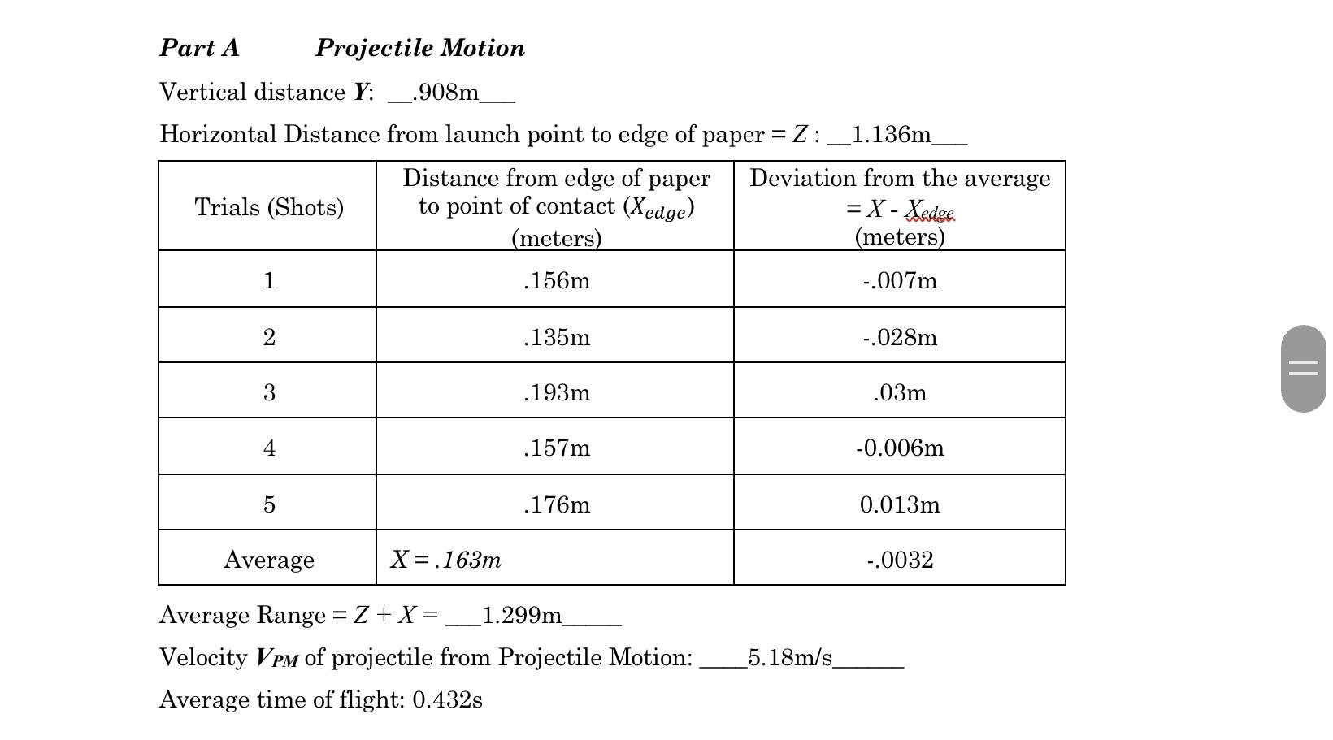
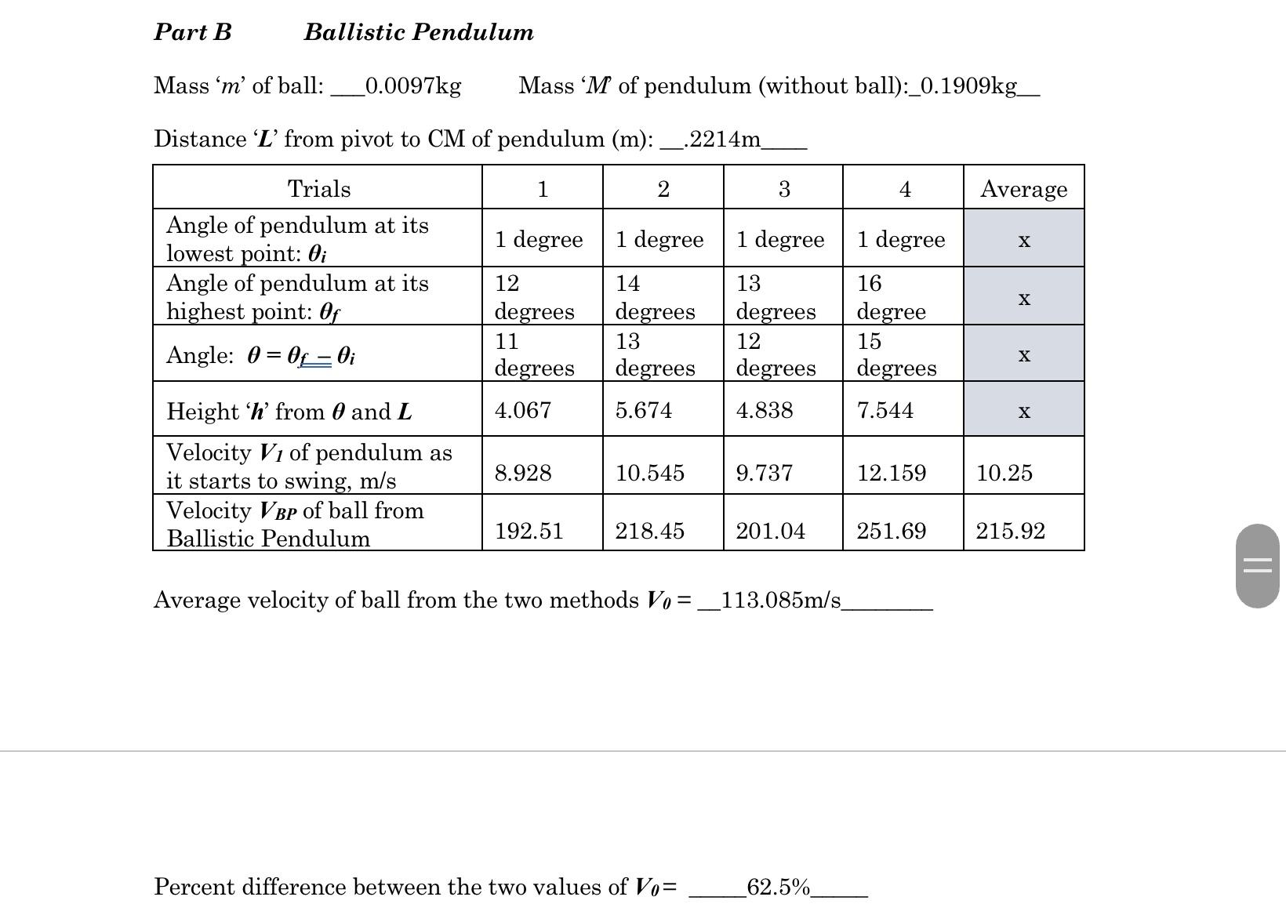
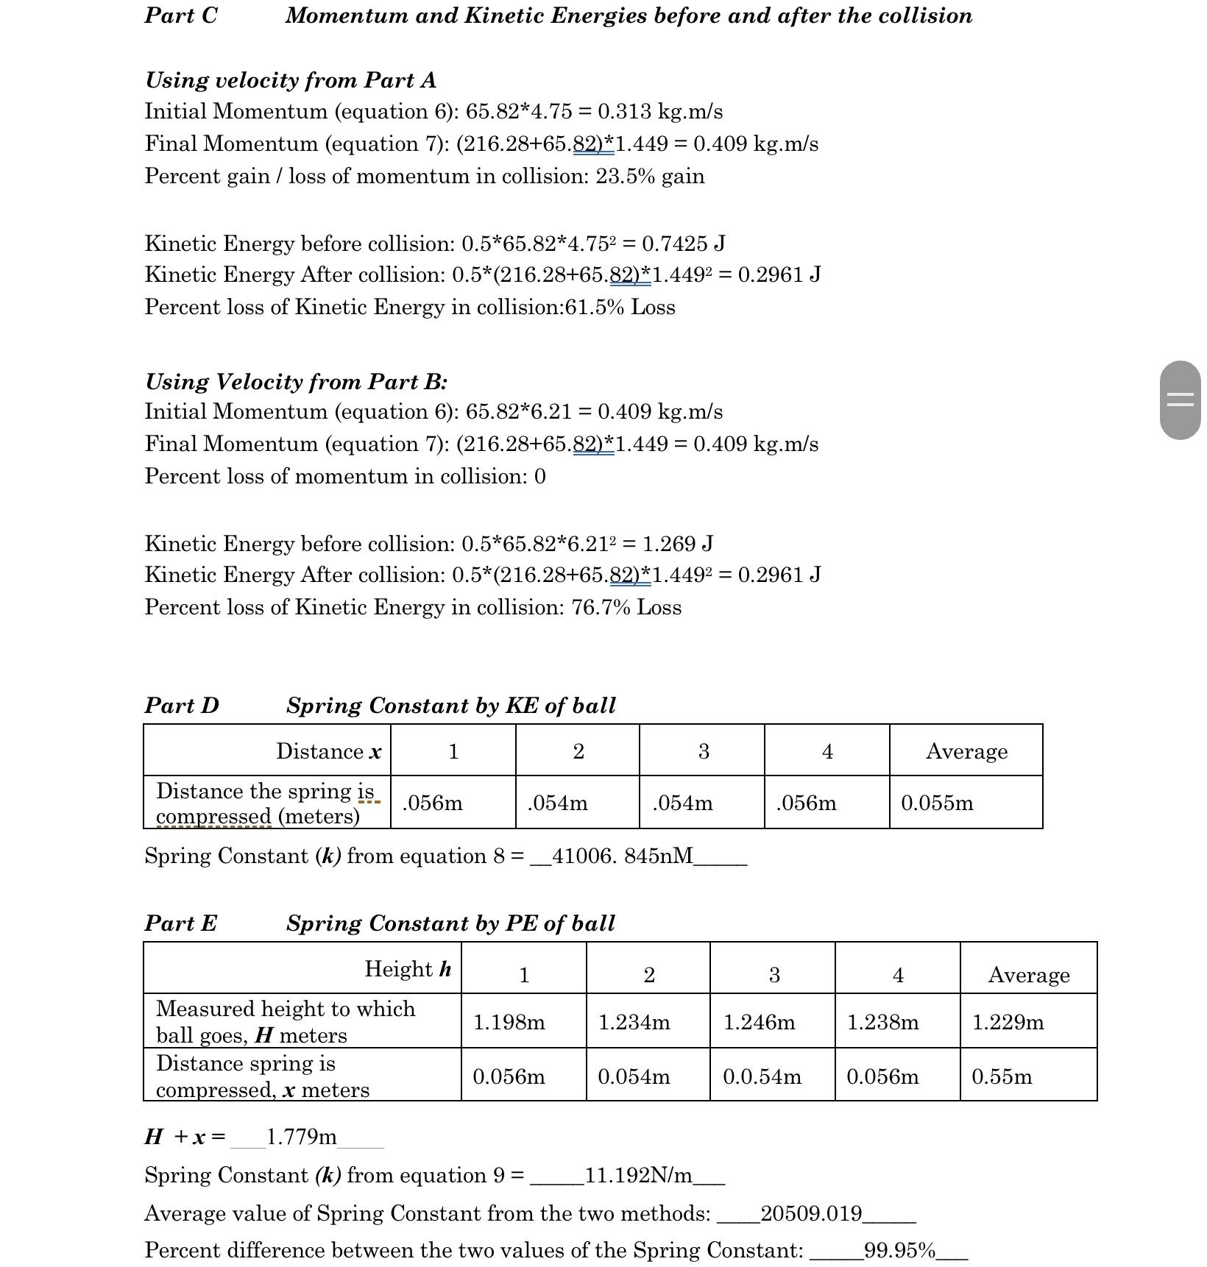
Part A: During the first part of the lab, the main goal was to obtain the average distance the ballistic pendulum would launch the ball. The ball was launched a total of five times. The measured distances did have a slightly bigger gap of numbers that did vary. After all five measurements were obtained the average distance and the deviation from the average were calculated.
Part B With a triple beam balance, the lab group attempted to measure the mass of the ball, however, the ball kept trying to roll off the plate. So, the group came up with an idea that involved a roll of tape. A lab member measured the mass of the roll of tape and then measured the mass of both the ball and the roll of tape combined. With the difference in both measurements, the group was finally able to get the ball's mass. Four different trials were run for this portion of the lab. The pendulum at rest ended up being the lowest point. For the angle and the heights measured, there was no need for the average value to be calculated. To obtain the velocity, one member from the group would release the pendulum from its starting point while another person would time the swings with their phone. The only times the average value had to be calculated was for the velocity of the swings. Once all four trials were run, the group calculated the average values.
Part D This portion of the lab consisted of the group measuring the springs constant inside the ball launcher in four different trials. From rest, the spring was released multiple times. During all four trials, the results were very similar to each other. In the end, after all trials were run the group calculated the average distance the spring was compressed.
Part E In the last portion of the lab to find the average value of springs constant of potential energy, The launcher was placed facing vertically up towards the ceiling. At first, the launcher was placed on a table, however during the first launch the group noticed the ball would pass the height of the meter stick so it was then decided to move the launcher onto the ground. To get the measurements as accurate as possible one lab member would launch the ball, the second member would hold a meter stick with a second one stacked on top of each other, and the third member recorded the launch. After each launch, the member who recorded the launch would rewatch the video and slowed it down to find the exact moment the ball launched to its maximum height before being pulled back down by gravity. After all four trials were run the average value was finally calculated.

CALCULATIONS:
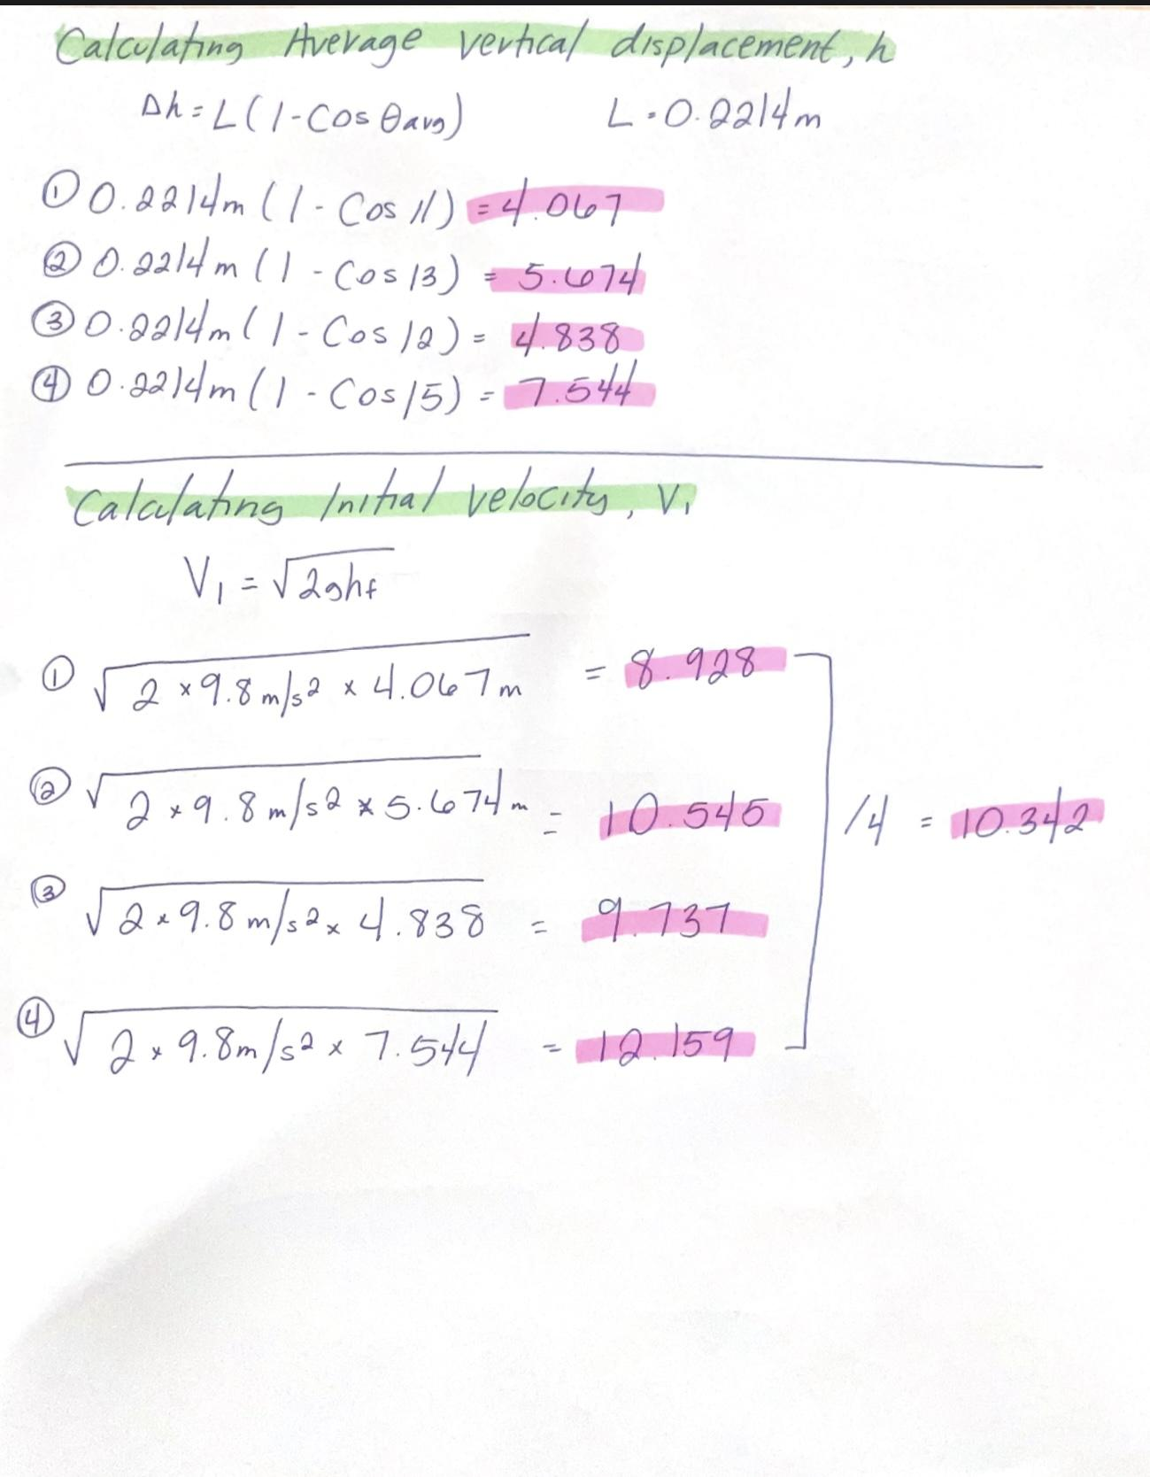
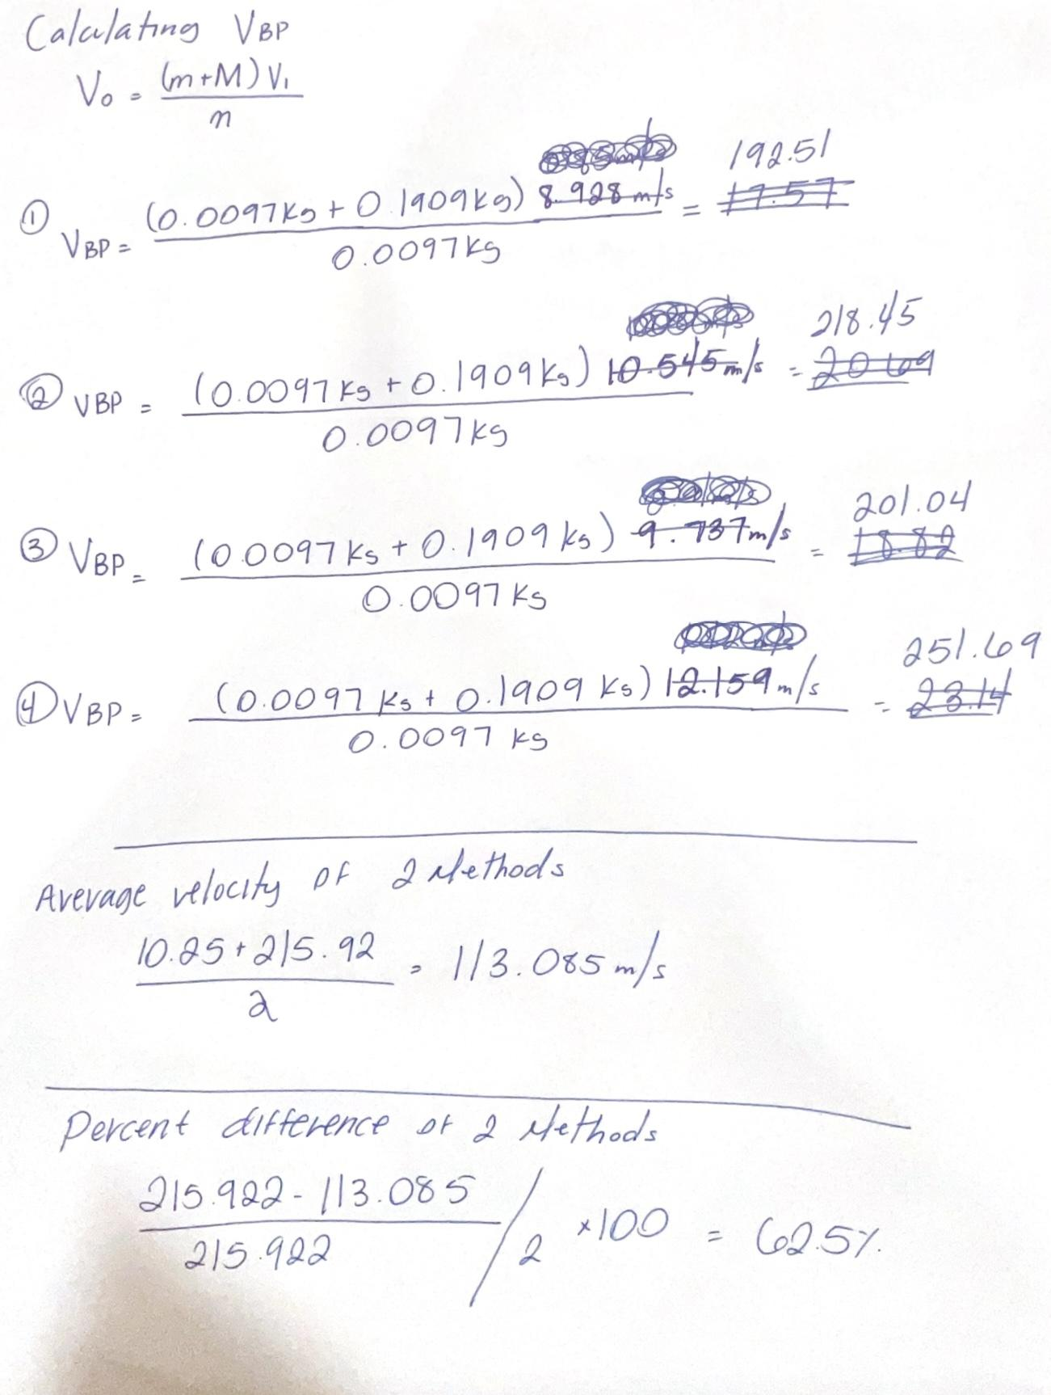
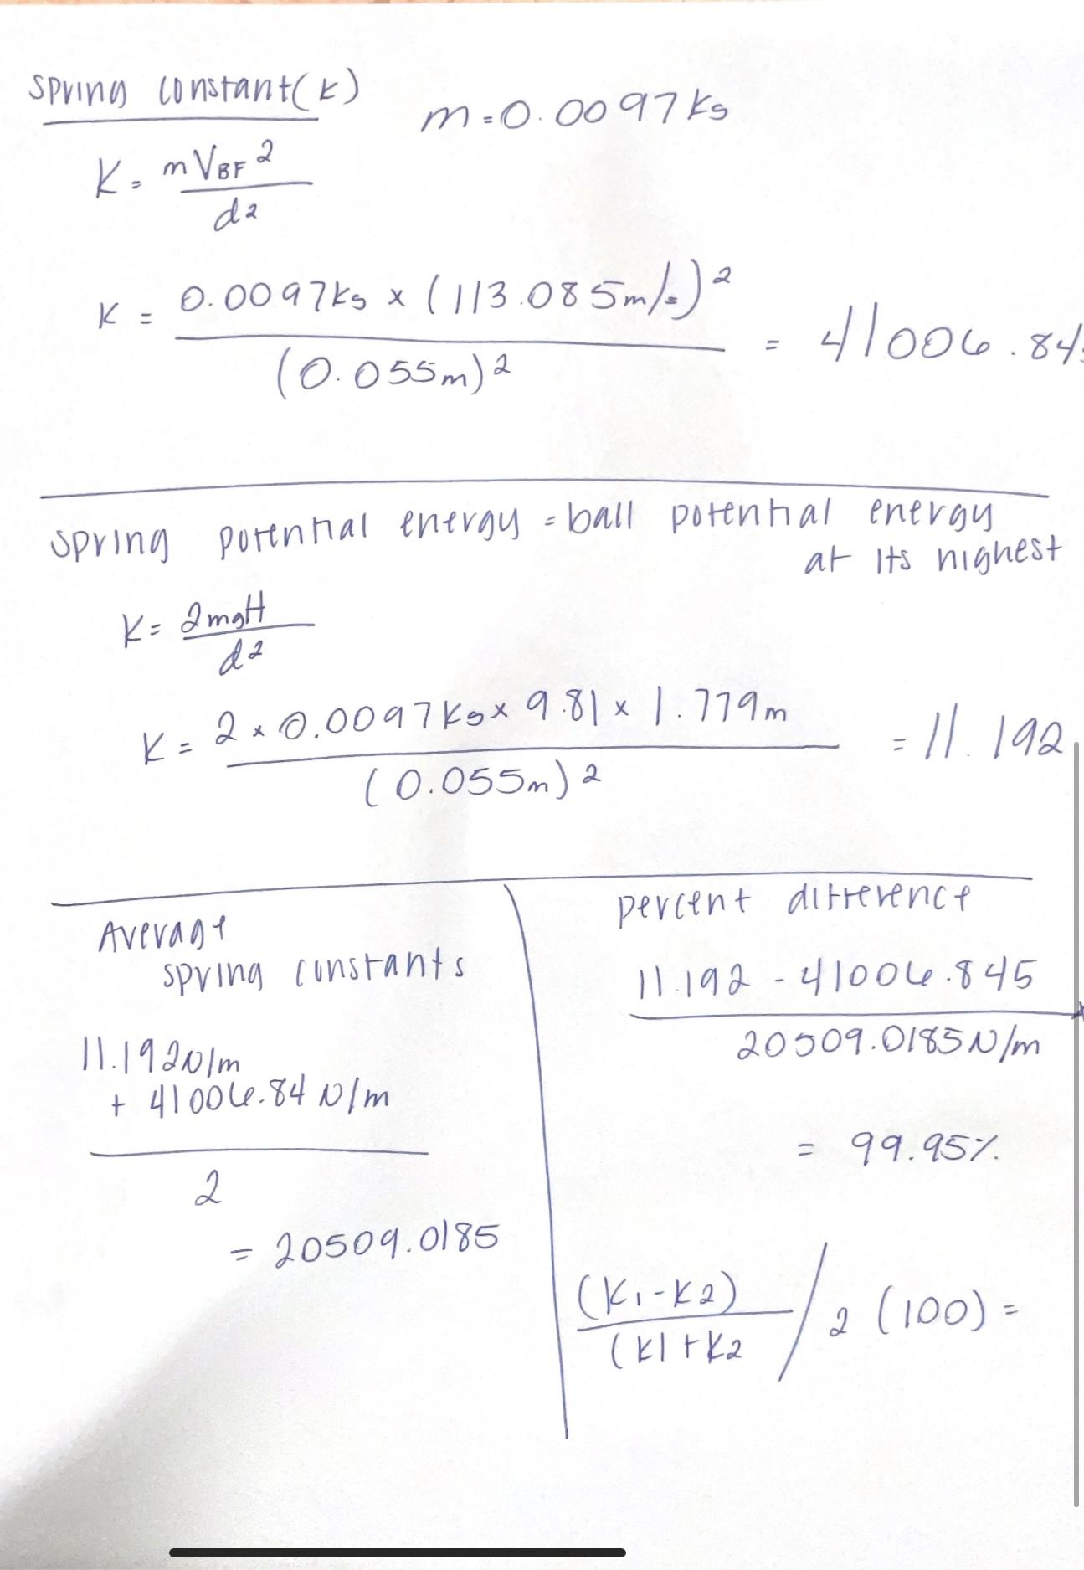
RESULTS:
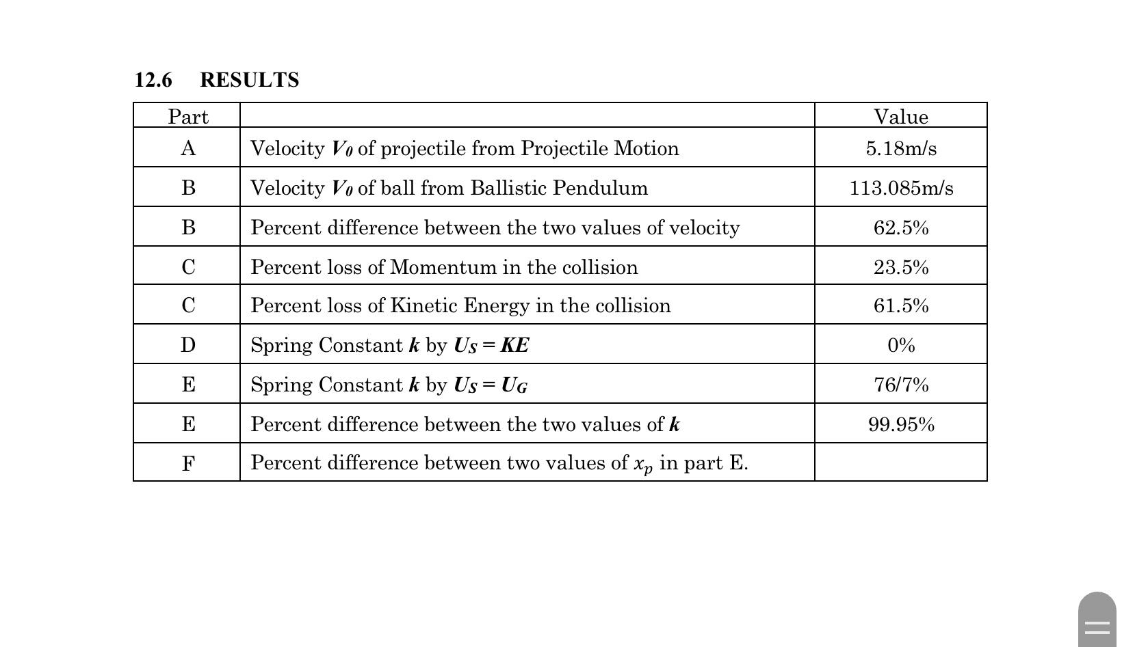
SOURCES OF ERROR:
- Measuring the maximum vertical height:
- Due to a lack of equipment, the plastic ball cannot be precisely measured at its highest point. The results are flawed when the phone's slow-motion camera mode and two meter sticks are hooked together.
- Timing Errors:
- Estimating the time of flight may make it harder to figure out how fast a projectile is moving. Using the stopwatch on the phone does not give the most accurate results because the time the plastic ball takes to hit the ground when launched is very fast; it takes less than 1 second for the ball to hit the ground.
- Air Resistance:
- Even if it is not much, air resistance can change the way a projectile moves and make it harder to figure out its speed.
- Measuring the horizontal distances:
- The pendulum launcher required it to be clamped down to the table from which it was being fired due to the force of the firing. This force had the noticeable strength to move the degree of the launcher and produce minor imperfections in its precision.
DISCUSSION:
The results gathered for the precision of the launcher were calculated based on the mass and spring’s energy, and then using the formulas for kinetic energy. This was then noted down and using that, the velocity of the ball could be determined and tested. Looking at the results gathered, this data determined the accuracy of the calculations done. Once the launcher’s accuracy was determined, the launcher was turned vertical to measure its maximum vertical height with the same energy and mass used prior. This information bears the largest chance for error as the method of using a phone camera and two meter sticks held together to get an approximation of the vertical height had multiple chances for human error such as; mishandling the meter sticks held at launch, the ball striking the meter sticks, and misreading of the phone video. After this was completed, the final part was to reintroduce the pendulum and measure the degree to which it was pushed after firing the ball into it with the same mass and energy as the prior parts of the experiment. Looking at the calculated angles of the experimental runs, the calculated results are within acceptable percent error.

CONCLUSIONS:
Using kinematic equations and a ballistic pendulum, this experiment was able to find out what the projectile's starting speed was. The results showed that momentum and energy are conserved, but they also showed that the two ways of measurement were not exactly the same when it came to accuracy.

